5-5. Alien Colors
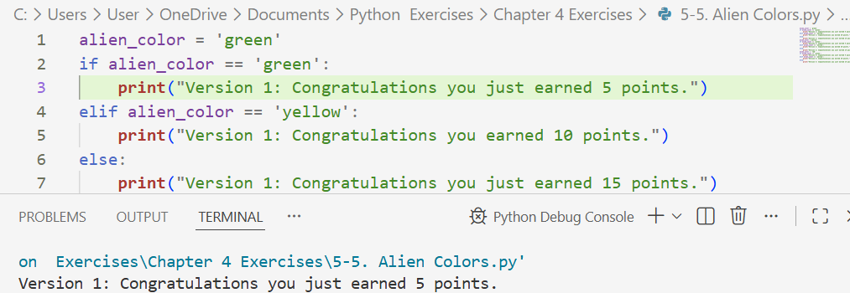
Green Version

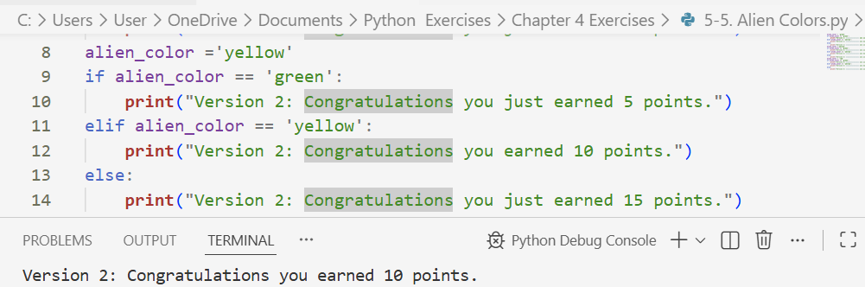
Yellow Version

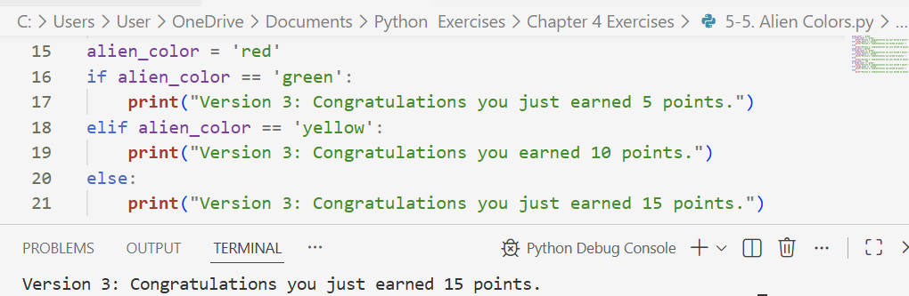
Red Version

